**How to Access Cognos**

**Before you begin**: You must be either on campus and attached to the campus network, or you must be logged into the Virtual Desktop Interface in order to access the report. For instructions on logging into VDI, visit this website: https://laverne.edu/technology/virtual-desktop/

1. Log into the portal and click on Cognos Production from the Staff Resources section.

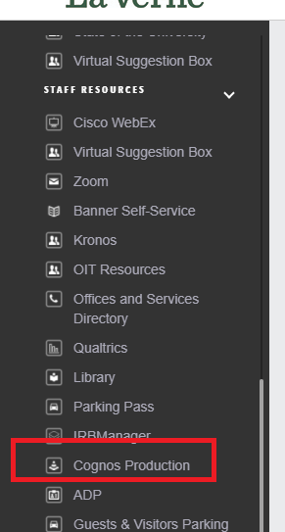

1. You should be logged into Cognos and see the landing page. Click on Team Content and then click on the Student Folder.

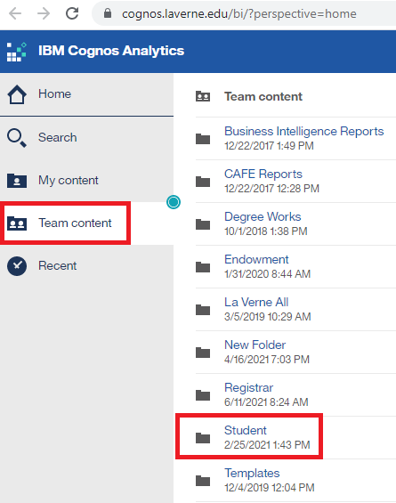

1. Click on Students Reports.

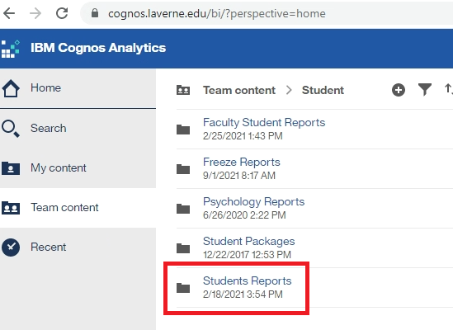

1. Click on Grading Students report.

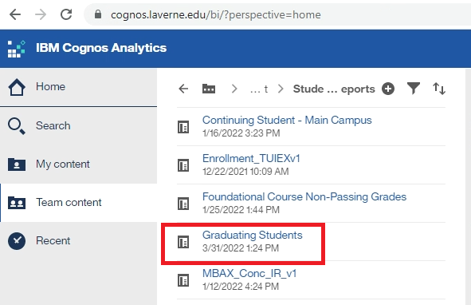

1. To run a list of completed (posted) students who have had their degrees conferred, leave the Cleared Term drop down to the default and select a Posted Term from the drop down:
   1. You can optionally select to filter by student level, student campus, or student advisor.
   2. You can only select one term at a time, so to run the report for multiple terms, you would need to run each term separately.

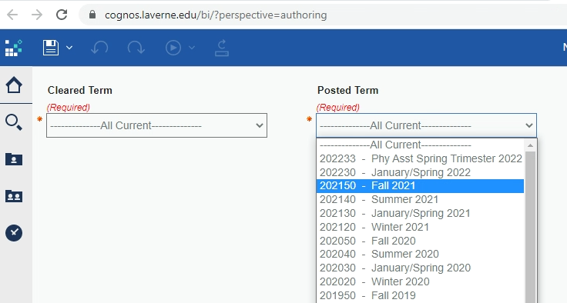

1. Click the Finish button at the bottom.

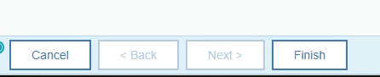

To Download as an Excel Spreadsheet, click on the down arrow next to the Run Report icon.

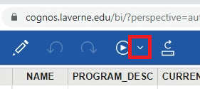

From the options, select Run Excel.

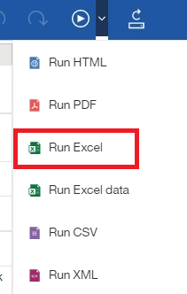

The file will run to your Downloads folder.